

**Department of Electrical Engineering**

Project Name:

ML Methods for Object Recognition in Dark

Student name: Rom Hirsch and Yarom Swisa

ID: 313288763 and

Mentor: Dr. Sasha Apartsin

Date of Submission:

|  |  |
| --- | --- |
|  | Mentor approval: |

**Table of Contents**

1. Abstract 3

2 Introduction 4

3 Goals 6

4 measures 6

4 Literature review 7

Low-Light Image Enhancement Methods. 7

Deep learning classification methods: 8

6 Methods 9

Block Diagram 9

Engineering challenge: 10

Division of work between the partners: 10

Required tools: 11

Products 12

work plan 13

1. References 14

# Abstract

Object classification is a key component in many modern systems.

Those systems rely on proper and accurate classification of objects to provide reliable service. One of the most influencing factors of object classification accuracy is illumination conditions. In this project we want to tackle the subject of

object classification in low-light images. We encounter low light images in many systems such as security footage, autonomous vehicles etc. This task of object classification becomes more challenging in low illumination images due color bias, unknown noise, detail loss and halo artifacts. We want to deal with that problem by using a deep learning model that will be able to handle with data with poor illumination conditions. During the project we will evaluates and test different methods to improve classification accuracy in low light images.

# 

# 2 Introduction

Image classification is a critical element in many computer vision systems. Robust image classification algorithms are important in many areas, such as traffic monitoring, collision avoidance, face recognition, etc.

**Classification** is a process of assigning a class to the context of an image. Some of the main classification methods based on Machine learning algorithms include Support Vector Machines (SVM), K-Nearest Neighbors (KNN), logistic Regression the biggest advantage of these classifiers is their ability to perform classification by using relatively small dataset. However, for large dataset and complex problems they limited. In order to deal with large dataset and complex problem there is classification methods based Neural Network (NN), NN provide good performance while working with large dataset.

**Neural Network (NN)** is a series of algorithms that endeavors to recognize underlying relationships in a set of data through a process that mimics the way the human brain operates. NN rely on training data to learn and improve their accuracy over time. NN architecture includes an input layer, hidden layer, and an output layer (figure 1).

Figure 1 – NN architecture example

In case of **image classification** by NN**,** the input dimension usually defined as Width*Height x 3 for RGB and Width*Height x 1 for gray scale format.

Hence the number of calculations that NN should perform in order to provide classification depends strictly on the image size. Extensive calculations are the main factor that limits the possibilities of NN to perform classification and detection on large size images. The most common methods for image classification are based on Convolutional Neural Network (CNN) architecture.

**Convolutional Neural Network (CNN)** is using a convolution in place of general matrix multiplication in their layers (figure 2). They are specifically designed to process pixel data and are used in image classification. Image classification with CNN works by sliding a kernel or a filter across the input image to capture relevant details in the form of features.

Figure 2- convolution operation

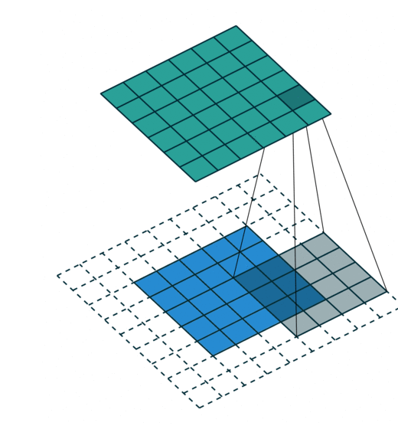

Low-light image classification is key component in many modern systems, such as surveillance, and autonomous driving etc.

Unfortunately, low light images Classification is challenging task because low-light conditions are not only low in brightness, but they also suffer from many problems such as color bias, unknown noise, detail loss and halo artifacts.

There are some methods to overcome this problem.

The first is to enhancement the low light images before passing through the classifier model and the second is train the classification NN model on low light images.

In this project we will use advanced low-light images enhancement methods and evaluate their contribution to the classification accuracy. The results will be compared with a model that train from the beginning for low-light images.

This project will be focused on research of low-light images classification accuracy improvement. The original problem can be formulated as following questions:

* What low-light image enhancement methods can be used to improve classification accuracy of deep learning model.
* Are combine of low-light images in training set will improve classification accuracy of deep learning model.
* Which is the best method for improve the classification accuracy of deep learning model.

# 3 Goals

The goal of this project is to implement and compare the different methods of dealing with low light image classification:

* Image enhancement before using image classification model.
* Train the image classification with low light images.

We will compare the results of the difference approaches and evaluate the best solution.

The main goal could be achieved by several sub goals defined as:

* Create photo-realistic algorithm to create low light images.
* Implement image enhancement algorithms.
* Implement NN classification model.
* Performance analysis and comparison

# 4 measures

* Create photo-realistic algorithm to create low light images.

In order to evaluate the algorithm, we will collect images that have normal and low light images and compare the images.

* Our measurement for success is the classification accuracy for the different methods we will use.

# Literature review

## Low-Light Image Enhancement Methods.

Low light Image enhancement has three main categories:

1. The first category methods are based on the histogram equalization (HE) - contrast adjustment using the images histogram
   * Dynamic histogram equalization (DHE) [1] - divides the histogram of the image into subblocks and uses HE to stretch the contrast for each subblock.
   * Adaptive histogram equalization (AHE) [2] - changes image contrast by calculating the histogram of multiple local areas of the image and redistributing the brightness.
2. The second category methods are Methods based on Retinex Theory [3] - that assumes that an image is a combination of reflection and illumination. Such methods maintain the consistency of the reflectance, increase the brightness of the illumination, and then take the pixel-wise product to enhance the low-light image.
   * Low-light Image Enhancement via Illumination Map Estimation (LIME) [4] – is enhance a low-light image by estimating its illumination map.
   * Single Scale Retinex (SSR) [5] aims to restore the brightness of illumination after Retinex decomposition
   * Multi-Scale Retinex (MSR) [6] combines the filtering results of multiple scales based on SSR, MSR adds a color recovery factor to tackle the color distortion caused by contrast enhancement in local areas of the image.
3. The third category is deep learning based methods– a great number of state-of-the-art methods have been developed for low-light image enhancement such as:
   * LLNET [7] – is a DP model for enhancing lightness and denoising images.
   * Branch Low-Light Enhancement Network (MBLLEN)][8] - uses multiple subnets for enhancement and generates the output image through multi-branch fusion.
   * RetinexNet [9] - decomposes low-light input into reflectance and illumination and enhances the lightness over illumination.

## Deep learning classification methods:

1. Deep Residual Learning for Image Recognition (ResNet) [10] is a common neural network (NN) architecture used for deep learning computer vision applications like object detection, image segmentation and image classification. In this network use a technique called skip connections. The skip connection skips training from a few layers and connects directly to the output (figure 3).

The approach behind this network is instead of layers learn the underlying mapping, we allow network fit the residual mapping.

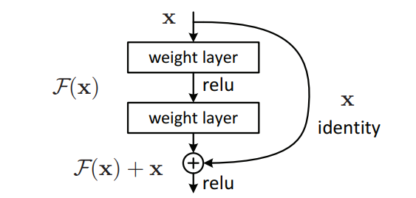

Figure 3 - skip connection technique

This architecture allows a depth of up to 150+ layers that allow high accuracy, the method has led to a breakthrough in the field of classification and identification accuracy. The method is still relevant and there are various improvements methods of it such as ResNet200 [11].

1. Rethinking Model Scaling for Convolutional Neural Networks (EfficientNet) is a convolutional neural network architecture and scaling method that uniformly scales all dimensions of depth/width/resolution using a compoundcoefficient. Unlike conventional practice that arbitrary scales these factors, the EfficientNet scaling method uniformly scales network width, depth, and resolution with a set of fixed scaling coefficients. EfficientNets also transfer well and achieve state-of-the-art accuracy on CIFAR-100 (91.7%), Flowers (98.8%), and 3 other transfer learning datasets, with an order of magnitude fewer parameters.

# 6 Methods

## Block Diagram

2. Evaluate accuracy Model trained on Normal images

Implement and train

Analyze

1. Prepare dataset

Select dataset

Augment photo realistic low-light images

3. Evaluate accuracy Model on enhance images

4. Evaluate accuracy Model trained on low-light images

Implement enhancement methods

Analyze

Analyze

Implement and train

5. Comparison between the different methods and drawing conclusions

1. Prepare dataset – select proper dataset that contain Normal images for classification and implement low illumination augmentation method to create low light images dataset.
2. Evaluate Accuracy Model trained on Normal images – train the model on Normal images and analyze the accuracy of normal images and low light images.
3. Evaluate accuracy Model on enhance images – test the trained model by passing through it enhance images from different methods and analyze the accuracy impact.
4. Evaluate Accuracy Model trained on low-light images – train the model with combine of low-light images and analyze the accuracy of the model.
5. Comparison between the different methods and drawing conclusions – compare all the methods and evaluate the best Method for improve classification accuracy on DP model.

# Engineering challenge:

* Develop an accurate model for creating photo-realistic images.
* Create work environment that will support:
  + Managing the dataset.
  + Train NN model.
  + Managing multiple scenarios and tests.
  + Save and analyze the tests results.
* Intergrade different computer vision and image process libraries.

# Division of work between the partners:

Rom Hirsch:

* Implement enhance images methods on the dataset.
* Implement analyze tools for measure the enhance images.

Yarom Swisa:

* Develop photo-realistic model for create low-light images.
* Implement analyze tools for measure the syntactic images compare to real low light images.

Two project partners:

* Select dataset.
* Select image classification model.
* Select enhance image methods.
* Implement work environment.
* Run classification tests.
* Comparison between the different methods and drawing conclusions.

## 

# Required tools:

Programs language:

* + - Matlab
    - Python

Develop environments and data analysis:

* + - Microsoft Windows 10
    - Strong computer with GPU
    - EDI python
    - MATLAB

# Products

* Review of the best solution for improve low-light image classification on deep learning model.
* Analyze and compare the different proposed methods.

## work plan

# References

1. A Dynamic Histogram Equalization for Image Contrast Enhancement
2. Adaptive histogram equalization and its variations, Computer vision, graphics, and image processing, vol. 39, no. 3, pp. 355–368, 1987.
3. The retinex theory of color vision, Scientific American, vol. 237, no. 6, pp. 108–129, 1977.
4. Lime: Low-light image enhancement via illumination map estimation, IEEE Transactions on image processing, vol. 26, no. 2, pp. 982–993, 2016.
5. Properties and performance of center/surround retinex, IEEE transactions on image processing, vol. 6, no. 3, pp. 451–462, 1997
6. A multiscale retinex for bridging the gap between color images and the human observation of scenes,” IEEE Transactions on Image processing, vol. 6, no. 7, pp. 965–976, 1997.
7. Llnet: A deep autoencoder approach to natural low-light image enhancement, Pattern Recognition, vol. 61, pp. 650–662, 2017.
8. Mbllen: Low-light image/video enhancement using cnns in BMVC, 2018, p. 220.
9. Deep retinex decomposition for low-light enhancement, arXiv preprint arXiv:1808.04560, 2018
10. Deep Residual Learning for Image Recognition
11. Revisiting ResNets: Improved Training and Scaling Strategies
12. EfficientNet: Rethinking Model Scaling for Convolutional Neural Networks